**Business Requirement Document (BRD)**

Meal Magic

**StakeHolder's Panel**

* Raj Mukhral, Trainer
* Sneha Larwal, Dietician
* Dixita Agarwal, Foodie

**Needs/Interview Overview**

Having a word with the stakeholders few of the major points which came to light were

* Need for a forum/application where cumulative details of recipes and ingredients can be displayed.
* There are instances where a person speaks about their favourite dishes and/or, one has no idea about the taste the person has.
* FitnessFreaks hover on the online platforms to search for their diet which is wrong like diet should be to their interests.
* Having put all the ingredients at the home for a particular dine is not possible always.

**Approach**

Since we have got our requirements we have our approach towards the same in shape. So here it goes.

* A web page including the normal user login and logout system, a search bar for the user's to search for the recipes.
* Cumulation of recipes based on different ingredients.
* Suggestions for random recipes to the users based on the user's favourite recipes.
* Making up of a text reader which predicts the taste of the person from the text entered.

**Functionality**

* Landing into the web page the user will be able to search for the recipe which he/she wishes to search for. After typing in the dish name one needs to select/enter the Search Recipe Button.
  + This will show the list of recipes relevant to the name entered by the user.
  + Adding to this if the user wishes to download it over their devices so we have an option of
    - Downloading in PDF/PNG format
    - Sharing over platforms including Whatsapp or Twitter
  + Additionally, if the user wishes to get some daily random recipes to be there every time he/she visits the webpage then the user must have an account registered.
* Secondly, a form type interface will be there.
  + For the users who are into fitness, they can enter down the amount of protein/carbs which he/she wishes to intake, entering the same it will display out the recipes relevant to the same.
  + The user needs to type in the ingredients available with him/her at present. Following which the user will be shown the list of dishes/recipes which can be prepared from the ingredients entered.
* Lastly, a textbox input will be shown wherein the user needs to enter a text describing out his/her favourite dishes or so. The result will be the text with the highlighted words. The highlighted words will be from the dishes and/or the ingredients from the text entered.

[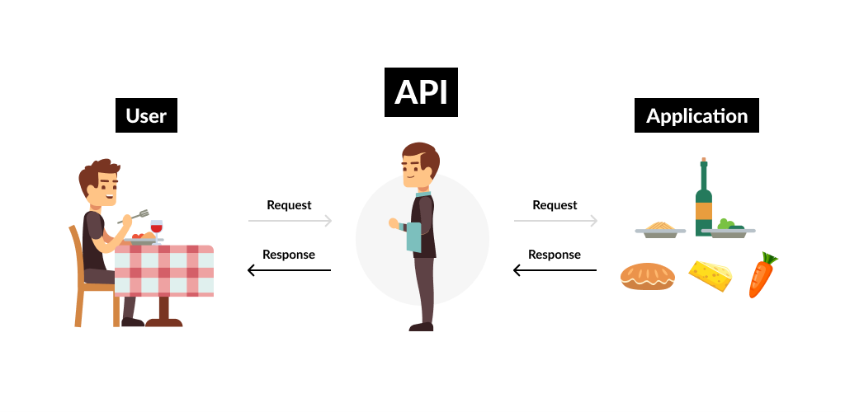](https://user-images.githubusercontent.com/62371149/123507729-b4136b80-d688-11eb-9ffd-95a8a87dcf94.png)

**Development**

* Starting with we will create a web application/web page that will be built over HTML, CSS with ReactJS Framework.
* Using [spoonacular API](https://spoonacular.com/food-api) and creating the API Key.
* User makes an account(optional), mandatory if he/she wants recommendations for the recipes.
* Storing the searches into a database according to the user's account to analyze the searches to give recommendations for daily recipes.
* Input form for taking in the inputs and fetching out the relevant details from the API.
* Configuring the API and the development according to the input data.
* Deployment

**Project SCOPE**

* FitnessFreaks who are concerned about the daily intake of proteins, carbs can take down a meal plan and make it suitable according to their needs.
* People who are much more into food and are looking out for new variants of cuisine daily, can be benefited from this.
* Daily random recipes based on user's search

**Technology / TechStack**

* Basic Languages - HTML, CSS, JS
* FrameWork - ReactJS
* Backend - NodeJS
* Databases - SQL / MongoDB
* API - [spoonacular API](https://spoonacular.com/food-api)